AWS Web Application Firewall (WAF)
1. What is AWS WAF?
AWS WAF is a Web Application Firewall. It protects websites and APIs from unwanted or malicious HTTP and HTTPS requests.
EASY DEFINITION AWS WAF checks a web request before it reaches the application. Based on rules, it can allow, block, count, or challenge the request.

Simple example
A user opens your website. WAF checks the user’s IP address, requested URL, headers, query string, and other request details. A normal request is allowed. A known attack can be blocked.

What attacks can WAF help stop?
- SQL Injection (SQLi)
- Cross-Site Scripting (XSS)
- Bad bots and web scrapers
- Too many requests from one IP address
- Requests from unwanted IP addresses or countries
- Requests to sensitive paths such as /admin

What can AWS WAF protect?
AWS resource | Example
CloudFront | Static website or global web application
Application Load Balancer | EC2 or Auto Scaling web application
API Gateway REST API | Backend REST API
Other supported services | AppSync, Cognito, App Runner and others

2. How AWS WAF works
The main WAF resource is called a Web ACL. The Web ACL contains security rules and is attached to CloudFront, an ALB, API Gateway, or another supported resource.
REQUEST FLOW User → CloudFront / ALB / API Gateway → AWS WAF checks rules → Application

Main components
Component | Simple meaning | Example
Web ACL | Main security policy | Website-Web-ACL
Rule | Condition and action | Block /admin
Rule group | Collection of rules | AWS Managed Common Rules
IP set | List of IP addresses | Trusted office IPs
Default action | Action when no rule matches | Allow

Rule priority
WAF checks rules by priority. A smaller priority number runs first. For example, priority 0 runs before priority 10.
Priority | Rule | Action
0 | Allow trusted office IP | Allow
10 | Block /admin | Block
20 | Rate limit | Block
Default | No rule matched | Allow

3. WAF rule actions
Action | Meaning | Example
Allow | Send request to application | Normal website request
Block | Reject request | SQL injection request
Count | Record request but do not block | Test a new rule
CAPTCHA | Ask user to solve a puzzle | Suspicious login traffic
Challenge | Run a silent browser check | Possible bot traffic

BEST PRACTICE Create a new rule in Count mode first. Check genuine traffic and false matches. Change it to Block only after testing.

Common rule types
Rule type | Example
IP rule | Block 203.0.113.10
Country rule | Allow only required countries
Rate-based rule | Block an IP sending too many requests
URI path rule | Block /wp-login.php
SQLi rule | Detect SQL injection pattern
XSS rule | Detect script injection pattern
AWS Managed Rules | AWS-maintained common security rules

4. Real-time examples

Example 1: Online shopping website
During a sale, one bot sends thousands of requests and buys limited stock. WAF can apply rate limiting and bot protection to reduce automated traffic.

Example 2: Login page attack
An attacker tries many usernames and passwords on /login. WAF can rate-limit the login path and use CAPTCHA or Challenge for suspicious browser traffic. The application should also use MFA and account-lock controls.

Example 3: SQL injection
An attacker sends a query such as ?id=1 OR 1=1. A SQL injection rule can detect and block it. The application must still use parameterized queries and input validation.

Example 4: Admin page protection
A company wants /admin to be available only from the office public IP. Create an IP set for the office and allow /admin only from that IP range; block other requests to the path.

Example 5: Your static portfolio website
You can attach a global Web ACL to the CloudFront distribution for sspvenu8899.life. WAF checks requests reaching the site through CloudFront and can block bad IPs, suspicious paths, bots, and request floods.
IMPORTANT If the S3 website endpoint remains public, someone may reach it directly and bypass CloudFront and WAF. A stronger design uses a private S3 bucket, the S3 REST origin, and CloudFront Origin Access Control (OAC).

5. Simple CloudFront WAF demo
Goal: protect the CloudFront distribution used by sspvenu8899.life.

Step 1: Create Web ACL
- Open AWS Console → search for WAF & Shield.
- Choose Web ACLs → Create web ACL.
- Name: sspvenu-cloudfront-web-acl.
- Resource type: CloudFront distributions (global).
- Select your CloudFront distribution.

Step 2: Add AWS Managed Rules
- Choose Add rules → Add managed rule groups.
- Select AWS Managed Rules.
- Add Core/Common rule protection and Amazon IP reputation rules.
- For safe testing, override the rules to Count first.

Step 3: Add a simple custom rule
- Create a rule named Block-WordPress-Login.
- Inspect URI path.
- Condition: URI path exactly matches /wp-login.php.
- Action: Block.

Step 4: Test
- Open https://sspvenu8899.life — the home page should work.
- Open https://sspvenu8899.life/wp-login.php — WAF should block the request.
- Open WAF → Web ACL → Sampled requests and verify the matching rule.

Step 5: Monitor
- Enable CloudWatch metrics and sampled requests.
- Enable WAF logging if required. Protect or redact sensitive request fields.
- After reviewing Count results, change only confirmed rules to Block.

6. Monitoring and troubleshooting
Item | Purpose
AllowedRequests | Number of allowed requests
BlockedRequests | Number of blocked requests
CountedRequests | Matches recorded for testing
Sampled requests | Examples of requests that matched rules
WAF logs | Detailed traffic decisions
CloudTrail | Records who changed WAF configuration

If a genuine user gets 403
- Open WAF sampled requests or logs.
- Find the rule that blocked the request.
- Check IP, URL path, query string, headers, body, and rule labels.
- Change the rule to Count temporarily if needed.
- Create a narrow exception for genuine traffic; do not disable all protection.

7. WAF compared with other AWS security services
Service | Main purpose
AWS WAF | Protect HTTP/HTTPS web applications at Layer 7
AWS Shield | DDoS protection
Security Group | Control network access to resources such as EC2/ALB
Network ACL | Stateless subnet-level network filter
AWS Network Firewall | Control broader VPC network traffic

INTERVIEW POINT WAF protects web requests. Security Groups protect network access. Shield protects against DDoS attacks. These services work together.

Limitations
- WAF does not replace secure application coding.
- WAF does not replace authentication, authorization, MFA, or patching.
- WAF cannot inspect every possible business-logic attack.
- WAF protects supported HTTP/HTTPS resources, not all TCP/UDP traffic.

8. Important interview questions
Q: What is AWS WAF?
A: A managed Layer 7 firewall that protects web applications and APIs by checking HTTP/HTTPS requests against rules.
Q: What is a Web ACL?
A: The main WAF policy containing ordered rules and a default action.
Q: What are the WAF actions?
A: Allow, Block, Count, CAPTCHA, and Challenge.
Q: Why use Count mode?
A: To test a rule and identify false positives before blocking users.
Q: What is a rate-based rule?
A: It tracks request rates and acts when traffic exceeds the configured limit.
Q: Where do you create a CloudFront Web ACL?
A: Use CloudFront/global scope, managed through us-east-1.
Q: Where do you create an ALB Web ACL?
A: In the same AWS Region as the ALB.
Q: WAF vs Shield?
A: WAF filters Layer 7 web requests; Shield focuses on DDoS protection.
Q: How do you troubleshoot a WAF block?
A: Check sampled requests/logs, identify the terminating rule, and add the narrowest safe exception.
Q: Can WAF replace secure coding?
A: No. It is an additional defense layer.

Short interview answer
ANSWER AWS WAF is a managed Layer 7 firewall. I create a Web ACL, add AWS Managed Rules and custom rules, and attach it to CloudFront, an ALB, or API Gateway. It can inspect IP addresses, countries, URL paths, headers, query strings, SQL injection, XSS, and request rates. I first use Count mode, check logs and sampled requests, tune false positives, and then enable Block.

9. Quick revision
Question | Remember
Main WAF object? | Web ACL
Protection layer? | Layer 7 - HTTP/HTTPS
Safe testing action? | Count
Common attacks? | SQLi and XSS
Traffic flood control? | Rate-based rule
CloudFront scope? | Global / us-east-1
ALB scope? | Regional
Monitoring? | CloudWatch metrics, sampled requests and WAF logs

Official references
- AWS WAF Developer Guide: https://docs.aws.amazon.com/waf/latest/developerguide/waf-chapter.html
- How AWS WAF works: https://docs.aws.amazon.com/waf/latest/developerguide/how-aws-waf-works.html
- Resources protected by AWS WAF: https://docs.aws.amazon.com/waf/latest/developerguide/how-aws-waf-works-resources.html
- AWS WAF pricing: https://aws.amazon.com/waf/pricing/
Pricing changes by usage and features. Check the official AWS pricing page before creating production resources.

Tasks on WAF:
Part 1: Create an API Gateway REST API
Step 1: Select the Region
In the AWS Console, select:
Asia Pacific (Mumbai) – ap-south-1
The API Gateway API and WAF Web ACL must be in the same Region.
Step 2: Open API Gateway
- Search for API Gateway.
- Open Amazon API Gateway.
- Click Create API.
You will see different API types.
Find:
REST API
Do not select:
HTTP API
WebSocket API
REST API Private
AWS WAF protection is associated with an API Gateway REST API stage.
Click:
Build
under REST API.

Step 3: Select the Example API
Under Create REST API, select:
Example API
The console should display an example API definition containing a /pets resource.
Configure:
API name: venu-waf-lab-api
Description: Temporary REST API for AWS WAF lab
Endpoint type: Regional
IP address type: IPv4
If the page uses an Import button, click:
Import
Otherwise, click:
Create API
The example API is useful because AWS automatically creates sample /pets methods and mock integrations. AWS Example API tutorial
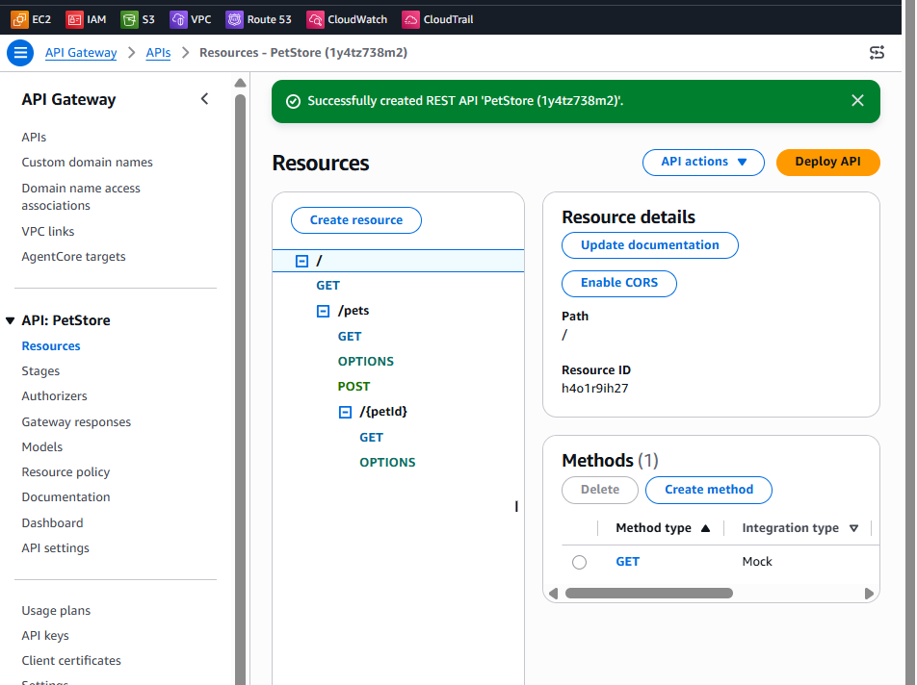

Part 2: Check the API resources
Step 4: Verify the resources
After the API is created, open Resources.
You should see resources resembling:
/
└── /pets
└── /{petId}
You should also see methods such as:
GET /pets
GET /pets/{petId}
Do not modify them for this basic lab.

Part 3: Deploy the REST API
Step 5: Deploy the API
- On the Resources page, click:
Deploy API
It might be inside the Actions menu.
- For Stage, select:
New stage
- Enter:
Stage name: dev
Stage description: Development stage for WAF lab
Deployment description: Initial WAF lab deployment
- Click:
Deploy
An API must be deployed to a stage before it can be invoked externally. AWS API deployment documentation

Step 6: Copy the invoke URL
After deployment:
- Open Stages.
- Select:
dev
- Copy the Invoke URL, which should resemble:
https://abc123.execute-api.ap-south-1.amazonaws.com/dev
Save this URL.
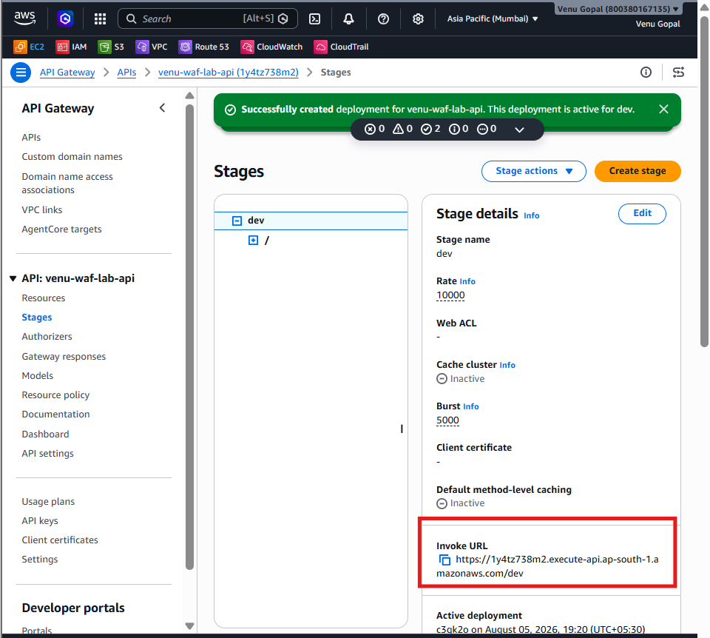

Part 4: Test before adding WAF
Step 7: Test /pets
Open:
https://abc123.execute-api.ap-south-1.amazonaws.com/dev/pets
Expected:
200 OK
You should receive sample pet data.
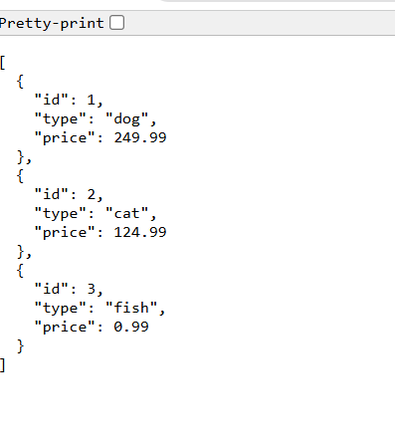
Step 8: Test /pets/1
Open:
https://abc123.execute-api.ap-south-1.amazonaws.com/dev/pets/1
Expected:
200 OK
Record or screenshot the successful response. After adding WAF, /pets/1 will be blocked.
Do not continue until both API URLs work.
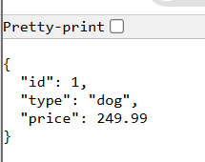

Part 5: Create the Regional WAF Web ACL
Step 9: Open AWS WAF
- Open AWS WAF & Shield.
- Confirm the Region is:
Asia Pacific (Mumbai) – ap-south-1
Do not use us-east-1 for this task.
- Select:
Protection packs (web ACLs)
- Click:
Create protection pack (web ACL)
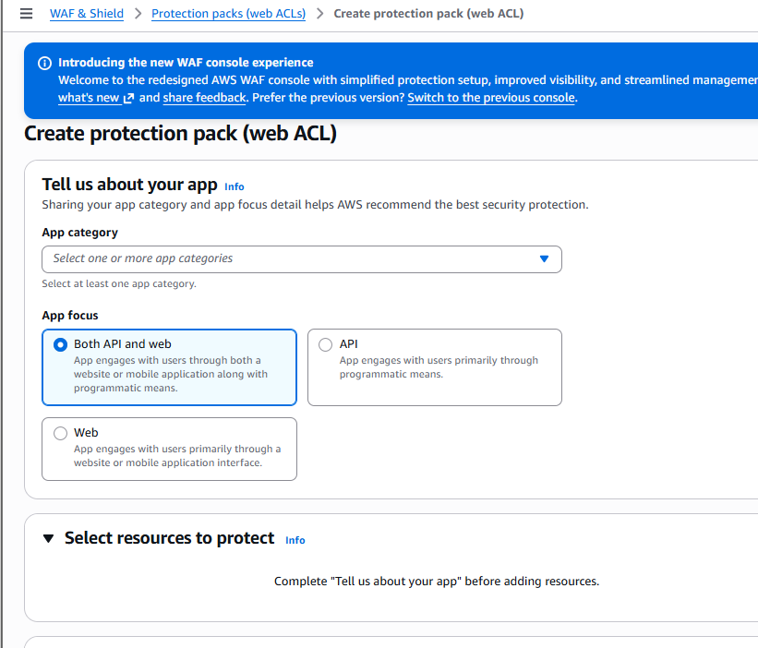

Step 10: Tell AWS about the app
For App category, select:
API & integration services
For App focus, select:
API

Step 11: Select the API Gateway stage
Under Select resources to protect:
- Click Add resources.
- Select or filter for:
API Gateway REST API
- Find:
venu-waf-lab-api
- Select the stage:
dev
- Select its checkbox.
- Click Add.
Confirm:
Select resources to protect (1)
WAF protection is associated with the deployed REST API stage, not merely the undeployed API definition. AWS WAF resource association

Part 6: Configure the protection pack
Step 12: Choose initial protection
For this basic lab, choose:
Individual rules
or skip the recommended protection packages if the console allows it.
Do not enable:
- Bot Control
- Account Takeover Prevention
- Account Creation Fraud Prevention
- CAPTCHA packages
- Advanced DDoS protection
Step 13: Name the Web ACL
Enter:
Name: venu-api-waf-lab-web-acl
Description:
Temporary WAF protection for API Gateway REST API
Confirm:
Scope: Regional
Region: ap-south-1
Default action: Allow
Default Allow means /pets and other requests will remain allowed unless a rule blocks them.

Part 7: Add the blocking rule
Step 14: Open the custom-rule builder
Expand:
Customize protection pack (web ACL) – optional
Select an option such as:
Add custom rule
Add rule
Create my own rule
If custom rules aren’t available during creation:
- Create the protection pack.
- Open venu-api-waf-lab-web-acl.
- Select Rules.
- Click Add rules.
- Select Add my own rules and rule groups.
- Choose Rule builder.
Step 15: Configure the rule
Enter:
Rule name: Block-Pet-One
Rule type: Regular rule
Statement:
Inspect: URI path
Match type: Exactly matches string
String to match: dev/pets/1
Text transformation:
None
If the console requires a transformation, select:
Lowercase
Step 16: Configure the action
Select:
Action: Block
Priority: 0
Enable:
CloudWatch metrics: Yes
Sampled requests: Yes
Metric name:
BlockPetOne
Save the rule and create/update the protection pack.

Part 8: Test WAF
Allow a short period for the WAF association to become active.
Step 17: Test the allowed URL
Open:
https://abc123.execute-api.ap-south-1.amazonaws.com/dev/pets
Expected:
200 OK
This request doesn’t exactly match /pets/1, so WAF allows it.
Step 18: Test the blocked URL
Open:
https://abc123.execute-api.ap-south-1.amazonaws.com/dev/pets/1
Expected:
403 Forbidden
This confirms that WAF blocked the request before API Gateway processed it.
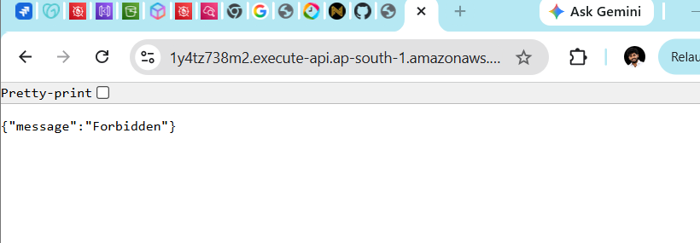

Part 9: Verify the WAF request
Step 19: Open sampled requests
Navigate to:
AWS WAF
→ Protection packs
→ venu-api-waf-lab-web-acl
→ Sampled requests
Look for:
URI: /pets/1
Action: BLOCK
Rule: Block-Pet-One
Also test /pets again. It should remain allowed.
